Jose F. Martinez Rivera

Course: ICOM4036 – 040

Prof. Wilson Rivera

April 29, 2013

**Problem – 2:** Discussion of Implementation and Results

**Implementation:**

The problem was divided into two source files for Broadcasting and Sending. Both implementations required memory allocation of a pointer with size of a char (1 byte) * 2 ^ 30 to get 30 bytes allocated. Consequently we have a for loop that increases the size of amount of data that is sent to the processors. Basically in each loop we send 2^N bytes of information to all the processes.

The problem was divided into two source files Problem-2-Bcast.c and Problem-2-Ssend.c and it follows the same structure provided. The transfers are sent in a for loop, but for the Ssend it is sent in a nested loop that transfers data to all the individual processes. The MPI_Barriers are used for synchronization and to correctly get the time in all the transfers. Two MPI_Barriers were used one before the transfer and one after the transfer to assure the data transfer is complete.

**Results:**

From the timing results (Results –Bcast.txt, Results-Ssend.txt­) on the end of the report we can graph the different times vs. the bytes of data (N):

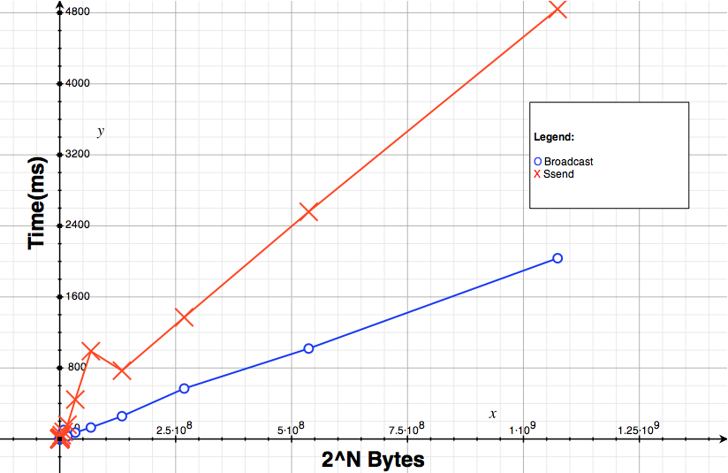

Figure 1 – Time (ms) vs. Bytes of data(B)

From the graph we can clearly see that sending data through a broadcast call is faster than sending it individually through a Ssend call. In the 2^30 bytes case the Broadcast call is 2.84s faster than the send call. Even though broadcasting is faster, we should use Ssend if we want to make individual transfers.

**Data of Results:**

The number of transfer indicates the N of 2^N of the bytes being transfer.

***Broadcasting:***

*Transfer: 0 took 0.000220 to complete.*

*Transfer: 1 took 0.000149 to complete.*

*Transfer: 2 took 0.000180 to complete.*

*Transfer: 3 took 0.000147 to complete.*

*Transfer: 4 took 0.000135 to complete.*

*Transfer: 5 took 0.000148 to complete.*

*Transfer: 6 took 0.000158 to complete.*

*Transfer: 7 took 0.000148 to complete.*

*Transfer: 8 took 0.000140 to complete.*

*Transfer: 9 took 0.000146 to complete.*

*Transfer: 10 took 0.000148 to complete.*

*Transfer: 11 took 0.000194 to complete.*

*Transfer: 12 took 0.000203 to complete.*

*Transfer: 13 took 0.000339 to complete.*

*Transfer: 14 took 0.000558 to complete.*

*Transfer: 15 took 0.000888 to complete.*

*Transfer: 16 took 0.002179 to complete.*

*Transfer: 17 took 0.002656 to complete.*

*Transfer: 18 took 0.003266 to complete.*

*Transfer: 19 took 0.007446 to complete.*

*Transfer: 20 took 0.014802 to complete.*

*Transfer: 21 took 0.019162 to complete.*

*Transfer: 22 took 0.053690 to complete.*

*Transfer: 23 took 0.102016 to complete.*

*Transfer: 24 took 0.033181 to complete.*

*Transfer: 25 took 0.072627 to complete.*

*Transfer: 26 took 0.129447 to complete.*

*Transfer: 27 took 0.256814 to complete.*

*Transfer: 28 took 0.568635 to complete.*

*Transfer: 29 took 1.018844 to complete.*

*Transfer: 30 took 2.036120 to complete.*

***Ssend****:*

Transfer: 0 took 0.004939 to complete.

Transfer: 1 took 0.000197 to complete.

Transfer: 2 took 0.000189 to complete.

Transfer: 3 took 0.000164 to complete.

Transfer: 4 took 0.000160 to complete.

Transfer: 5 took 0.000149 to complete.

Transfer: 6 took 0.000131 to complete.

Transfer: 7 took 0.000167 to complete.

Transfer: 8 took 0.000151 to complete.

Transfer: 9 took 0.000159 to complete.

Transfer: 10 took 0.000149 to complete.

Transfer: 11 took 0.000152 to complete.

Transfer: 12 took 0.000245 to complete.

Transfer: 13 took 0.000266 to complete.

Transfer: 14 took 0.000322 to complete.

Transfer: 15 took 0.000477 to complete.

Transfer: 16 took 0.000813 to complete.

Transfer: 17 took 0.001478 to complete.

Transfer: 18 took 0.002402 to complete.

Transfer: 19 took 0.004650 to complete.

Transfer: 20 took 0.009579 to complete.

Transfer: 21 took 0.019837 to complete.

Transfer: 22 took 0.043326 to complete.

Transfer: 23 took 0.080557 to complete.

Transfer: 24 took 0.161026 to complete.

Transfer: 25 took 0.444397 to complete.

Transfer: 26 took 0.989206 to complete.

Transfer: 27 took 0.769486 to complete.

Transfer: 28 took 1.370401 to complete.

Transfer: 29 took 2.558527 to complete.

Transfer: 30 took 4.841884 to complete.